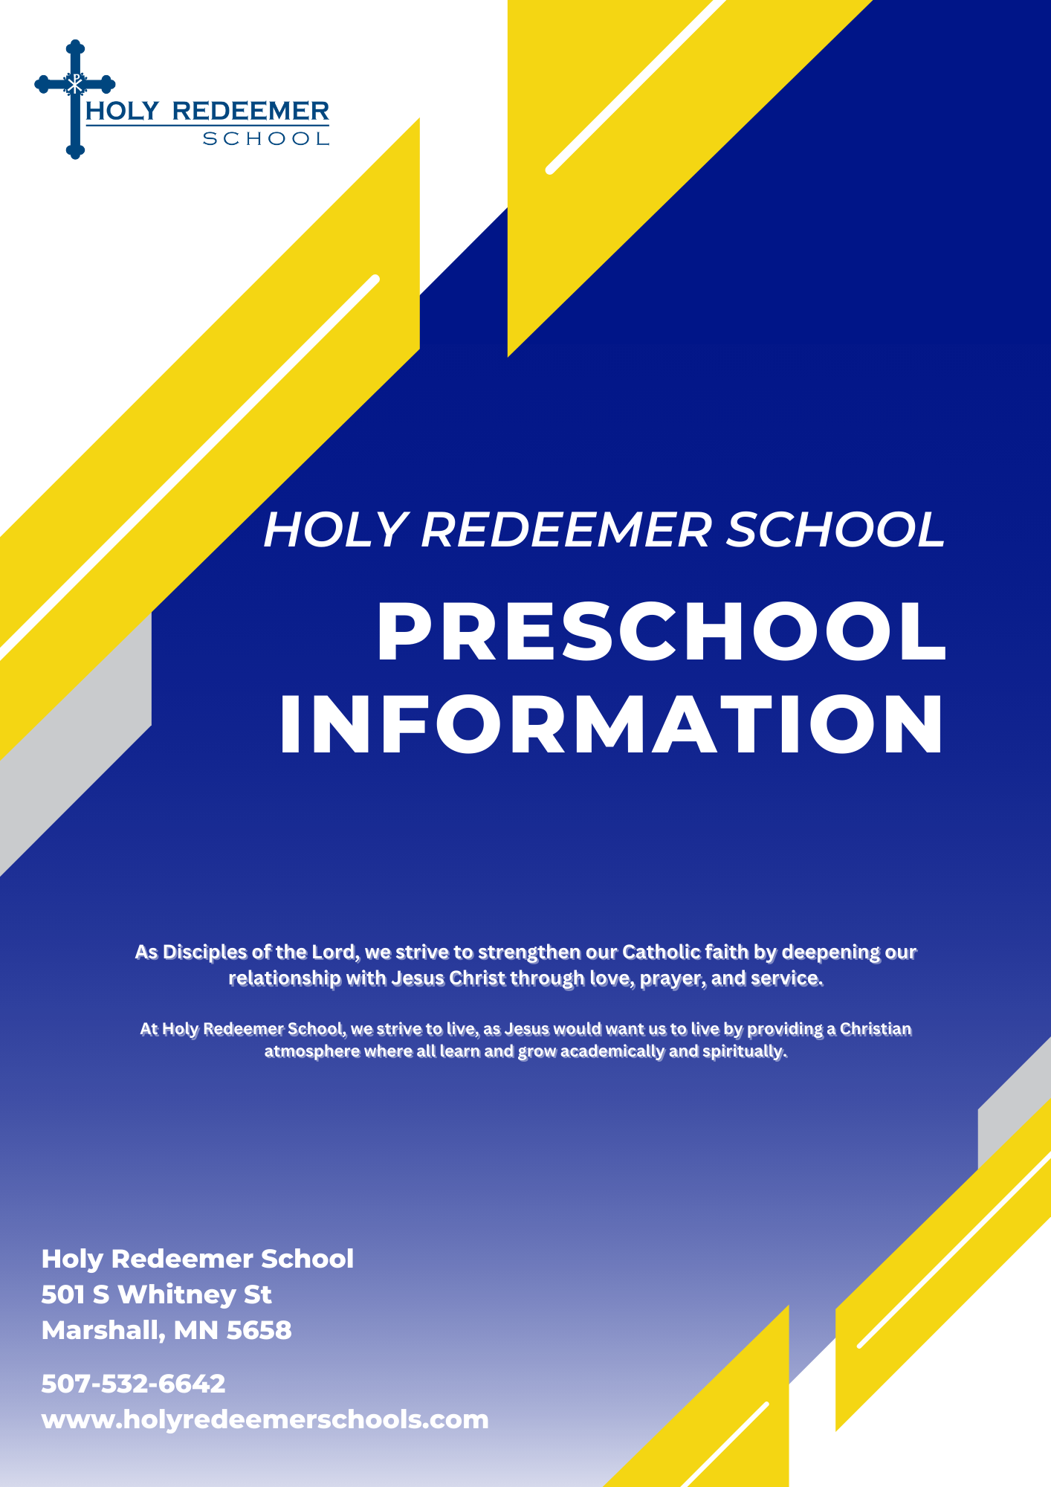

Table of Contents

Quick Facts…………………………………………..3
Preschool Religion..……………………………………..4
3 Year Old Class…………………………….....................5
4 Year Old Class…………………………….....................6
4/5 Year Old Class………………………………………….8
Tuition Cost…..…………………………………...…11
Other Information……………...…………………..12
-Lunch Prices
-Supply List
-Afterschool Care

Children that attend preschool need to be the age of the classroom they are attending by September 1st. Parents should communicate with the preschool director if you feel your child is ready for preschool and their birthday is between September 1st and November 1st.
All preschoolers must be potty trained.

Quick Facts

Holy Redeemer Preschool offers:

- A qualified and experienced staff
- A 1:10 teacher/child ratio
- Theme based teaching style
- Curriculum that is based on Early Childhood Learning Standards
- Separate classes for 3, 4, and 4/5 year olds
- Snacks and materials provided daily
- Child friendly toys, play areas, and discovery centers
- Clean, bright, and updated rooms
- A wide variety of learning manipulatives
- Access to age appropriate playground equipment
- Field trips and experiences
- Affordable tuition and competitive with daycare
- Two assessments yearly plus conference options
- Faith based curriculum weekly
- Consistent communication
- After school care option available

Preschool Religion

At all levels of preschool we use the Catechesis of the Good Shepherd program. This hands-on approach to discovering the faith is held in a special room called the atrium.

Atrium
The Catechesis of the Good Shepherd is an approach to the religious formation of children. It is rooted in the Bible, the liturgy of the church, and the educational principles of Maria Montessori. In this approach there is a room prepared for the children in which every object is to aid in their knowledge of God. It is a place of simplicity and order, prayer and work, and community. Everything in this room, known as the “Atrium”, is appropriate to the ages and sizes of the children who gather there.

Materials
The materials in the atrium are attractively displayed inviting children to explore the faith at their own pace. The shelves include maps of Israel along with miniature figures representing the elements of the parables and historical events from Scripture that have been shown to satisfy the spiritual needs of the children.
Children spend time enjoying and nurturing a relationship with the Good Shepherd. Materials and presentations on the life of Christ and His teaching help make the great mystery of who God is more understandable for the children.
- Through geography, the words of the prophets, and infancy narratives, Jesus is established as a real person.
- The Paschal narratives are treated similarly, using model cities of Jerusalem, empty tombs, and cenacles for the Last Supper.
- Selected parables further the child’s wonder and curiosity about the great mystery of the Kingdom of God.
- Children become familiar with the articles of Baptism, and gestures and articles of Eucharist.
- A prayer corner located in the atrium reflects the liturgical time of year with appropriate colors, prayer, songs, artwork, and readings.
The trained adults in the atrium or “catechists” present passages of Scripture and together they ask questions and wonder: “God who are you? How do you love us? What is the kingdom of God like? What is our place in it?”

3 Year Old Class
This age group meets on Tuesdays and Thursdays from 7:45 am - 3:00 pm. They will be provided with a morning and afternoon snack and eat the school lunch each day to meet the Department of Human Services (DHS) requirements. Our Religion and Catholic Faith are integrated on a weekly basis through The Catechesis of The Good Shepherd Curriculum.

In the 3 year old class the students will work on skills in the following areas:
- Fine Motor Skills
  - Cutting, writing, coloring
- Social Development
  - Initiate and engage in cooperative play
- Language and Literacy Development
  - Learn the letters of the alphabet with the correct sounds
- Enhancing Speaking and Listening Skills
  - Listen to stories, while understanding the content, and responding to directions
- Effectively Communicating
  - Needs, wants, thoughts, feelings
- Building Self-Esteem and Self-Confidence
- Eliminating Separation Anxiety from Parents
- Physical Development
  - Dance, artistic expression, and large motor skills
- Developing Interest in Mathematics
  - Awareness of counting, numbers, and sorting objects
- Science Concepts
  - Exploring and investigating the environment
- Awareness of Surroundings
  - Self, environment, and world
- Express Artistic Abilities in Projects and Crafts
4 Year Old Class
This age group meets on Mondays, Wednesdays, and Fridays from 7:45 am - 3:00 pm. They will be provided with a morning and afternoon snack and eat the school lunch each day to meet the DHS requirements. Readiness for Kindergarten is determined throughout the year by assessments, effective communication between parent and teacher, conferences, newsletters, calendars, and accomplishing the skills necessary to be successful in Kindergarten. Our Religion and Catholic Faith are integrated on a weekly basis through The Catechesis of The Good Shepherd Curriculum.

In the 4 year old class the students will work on skills in the following areas:
- Language and Literacy Development
  - Identify and write uppercase letters
  - Learn the correct letter sounds and associate with those letters sounds with the sounds in words
  - Use words to describe events and objects
- Fine Motor Development
  - Learn to write their own name
  - Learn how to hold a pencil correctly
  - Draw pictures to represent thoughts and ideas
  - Cut and enhance fine motor skills through: games, manipulatives, and activities
- Social Development
  - Initiate and engage in cooperative play
  - Sit and work close with other children
  - Be able to re-engage in play after completing activities
  - Develop appropriate actions and communication techniques to play with other children
  - Seek out other children for play purposes
  - Be imaginative in play
- Listening and Speaking Skills
  - Learn how to listen to stories while understanding the content
  - Make predictions from the story’s content
  - Complete two and three step directions
  - Complete tasks from teacher’s commands
  - Asking questions
  - Communicate ideas to others and respond to others through communication
  - Communicate their own needs, wants, and thoughts
- Building Self-Esteem and Self Confidence Skills
  - Learn how to accomplish tasks
    - Being responsible for putting your things in the correct place
    - Putting materials in your cubby
  - Get dressed in colder weather by zipping, dressing and using the bathroom
- Physical Development
  - Express themselves through dance, finger plays, songs, and artistic movement
  - Develop large motor skills by using playground equipment and engaging in outdoor games and activities
- Mathematics
  - Awareness and writing of numbers
  - Counting forwards and backwards
  - Sorting
  - Understand and create patterns
  - Use descriptive words to identify position
  - Recognize colors and geometric shapes
- Science
  - Exploration of a variety of materials
  - Use simple tools
  - Investigate objects indoors and outdoors
  - Use the sensory table for a wide variety of experiences
  - Conduct simple experiments
  - Actively observe things in our environment
  - Awareness of self, environment, and our world around us
- Art
  - Creating, constructing, and assembling art projects/crafts that correlate with the theme of the day/week

4/5 Year Old Class
This age group meets Monday-Friday from 7:45 am - 3:00 pm. They will be provided with a morning and afternoon snack and eat the school lunch each day to meet the DHS requirements. Readiness for kindergarten is determined throughout the year by assessments, effective communication between parent and teacher, conferences, newsletters, calendars, and accomplishing the skills necessary to be successful in kindergarten. Our Religion and Catholic Faith are integrated on a weekly basis through The Catechesis of The Good Shepherd Curriculum.

In the 4/5 year old class the students will work on skills in the following areas:
- Language and Literacy Development
  - Identify upper case letters of the alphabet and how to write them through weekly letter pages
  - Learn the correct letter sounds associated with the sounds in words
  - Use words to describe events and objects
  - Review letters throughout the day
  - Use words to communicate and express one’s self, describe events, and objects
- Fine Motor Development
  - Learn to hold a writing utensil correctly
  - Write their own name
  - Draw pictures to represent thoughts and ideas
  - Cut, and fold
  - Enhance fine motor skills though: games, manipulatives, and activities
- Social Development
  - Initiate and engage in cooperative play
  - Sit stand, wait, and work close to/with other children
  - Re-engage in play after completing activities
  - Development of appropriate actions and communication techniques to play with other children
  - Seek out other children for play purposes
  - Be imaginative in play
  - Being able to express and resolve disagreements involving other children while engaged in play.
- Listening and Speaking Skills
  - Learn how to listen to stories while understanding how a book is written and formatted
  - How words are read from left to right while comprehending the content and predicting the end result
  - Ask relevant questions regarding the content of the story
  - Being able to retell the story in the child’s own words
  - Complete two and three step directions
  - Complete tasks from teacher’s commands
  - Asking questions
  - Communicate ideas to others and responding to others through communication
  - Communicate one’s own needs, wants, and thoughts
  - Increase vocabulary and using words in conversation is also being developed
- Building Self-Esteem and Self Confidence Skills
  - Learn how to accomplish tasks
    - Be responsible for possessions and putting your things in the correct place
    - Daily arrival and dismissal procedures
    - Put materials in correct cubby
  - Get dressed in colder weather by zipping, dressing and using the bathroom
- Physical Development
  - Express themselves through dance, finger plays, songs, and artistic movement involving instruction, repetition and/or open ended movements
  - Develop large motor skills by using playground equipment and engaging in outdoor games and activities
- Mathematics
  - Awareness and writing of numbers
  - Count forwards and backwards
  - Write and recognize numbers
  - Count in sequence
  - Sort materials
  - Understand and create patterns
  - Use descriptive words to identify position
  - Recognize colors and geometric shapes
  - Understand simple units of measurement
  - Recall past events and use words like yesterday, tomorrow, etc.
- Science
  - Use senses to explore and actively investigate our environment
  - Use simple tools like binoculars, magnifying glasses, etc.
  - Use the sensory table for a wide variety of experiences
  - Conduct simple experiments
  - Awareness of self, environment, and our world around us
- Art
  - Create, construct, and assemble art projects/crafts that correlate with the theme of the day/week
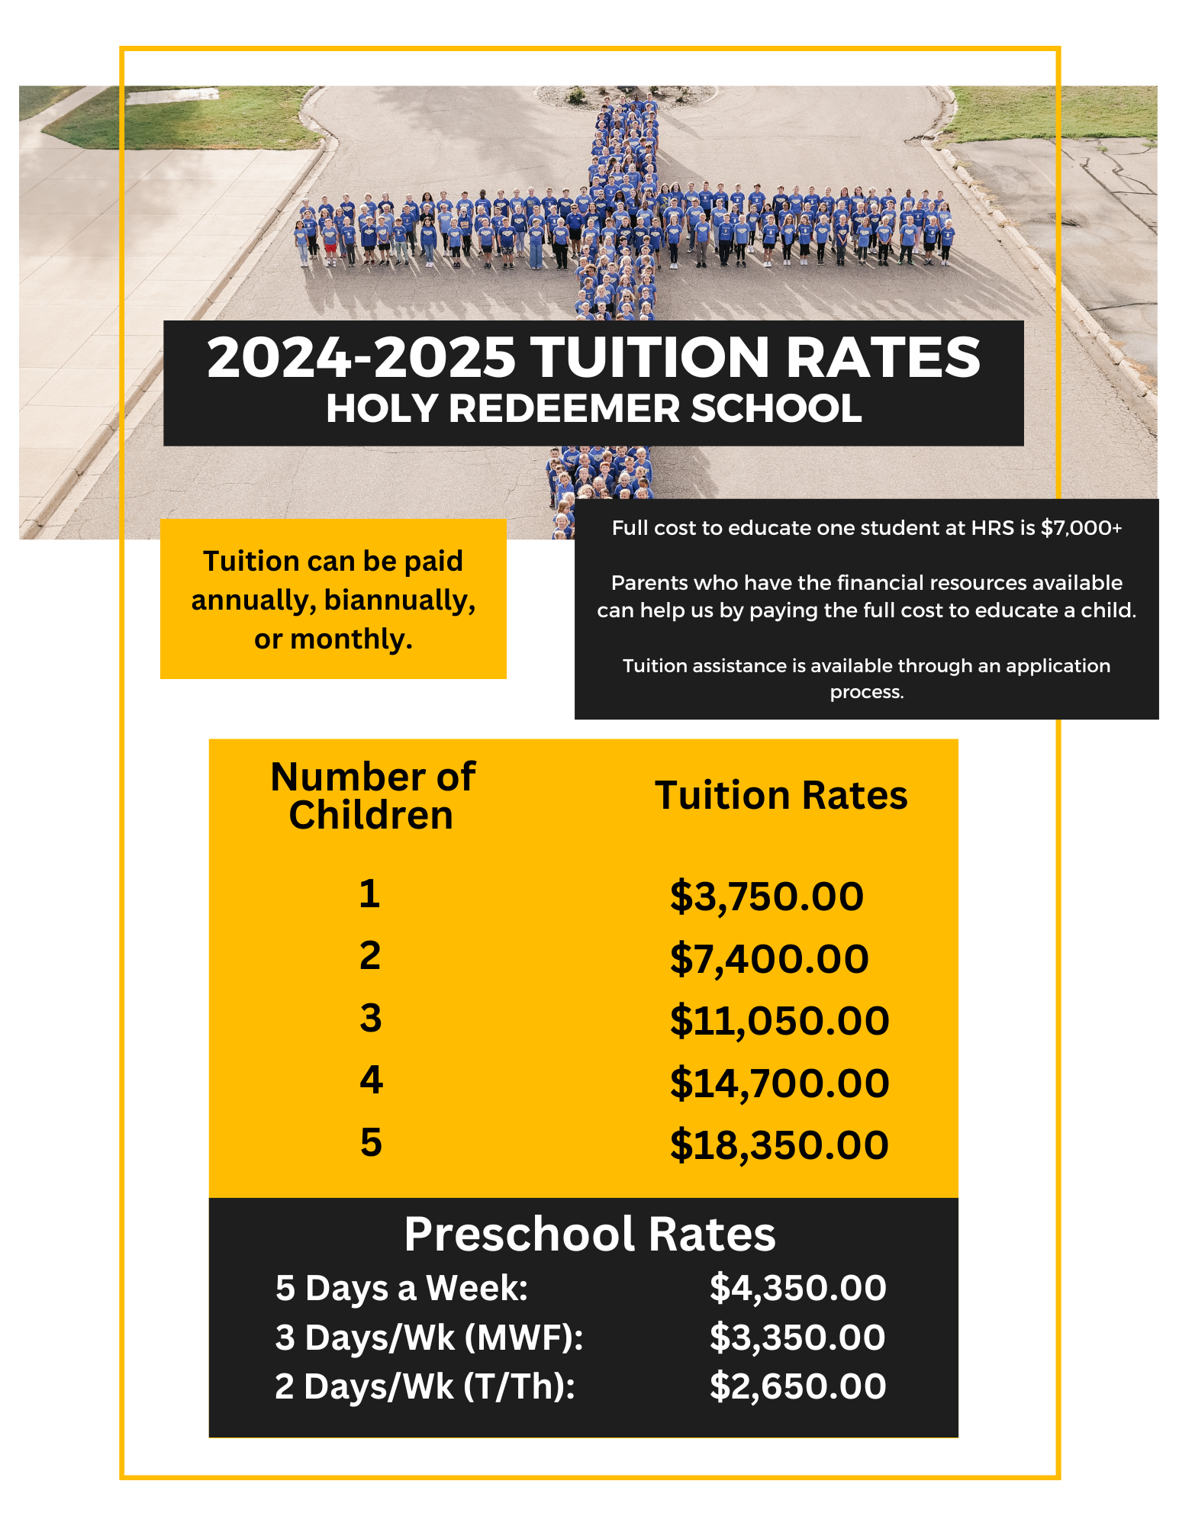
Other Information
Supplies
- 4 oz Elmer’s Glue Bottles - 2
- Elmer's Glue Sticks - 4
- Large box of Kleenex - 2
- Backpack or Bookbag
- $35 supplies fee

Afterschool Care
Holy Redeemer School offers an after school care program for all preschool age children. The program is held at the same time as the K-8 after school program (STARS) but the children are taken care of in separate locations within the building. The preschool after school care program is run by preschool staff members who are DHS licensed.
Cost: $7.00
Time: 3:00-5:30

